**[Supporting auto login for domain users](http://stackoverflow.com/questions/2500413/asp-net-active-directory-supporting-auto-login-for-domain-users)**

***Internet Explorer (I.E) settings:***

* **If the login box appears when trying to login with IE, there is a setting that you can set so that IE sends the username when used in the intranet sites. Go to tools > internet options > security and in the security settings select the option *Automatic Logon with current username and password* or *Automatic Logon only in intranet Zone* You have to make sure that the site you are trying to use is added in the intranet zone.**

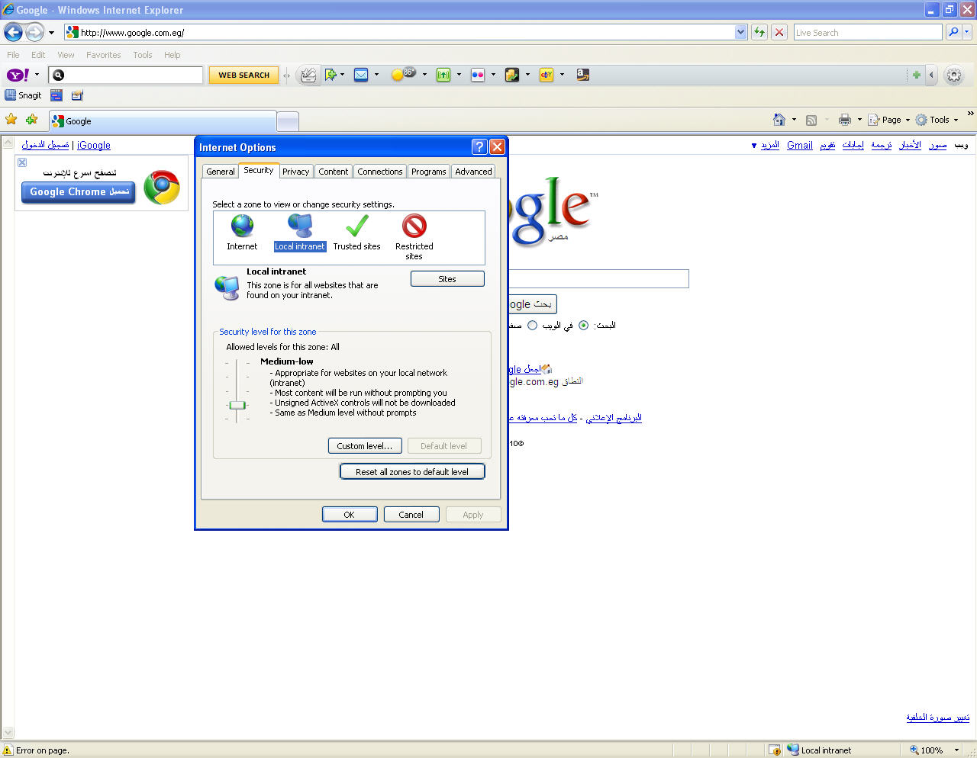

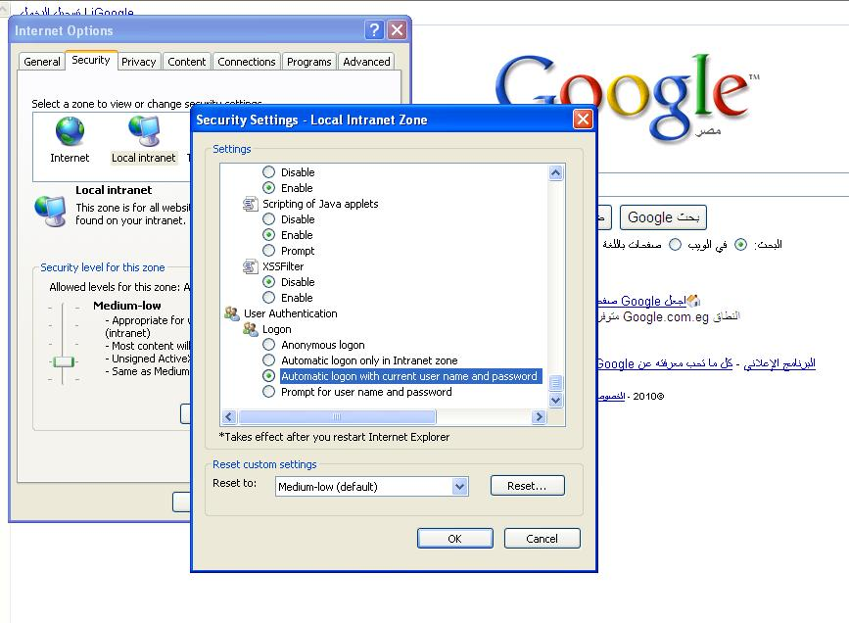

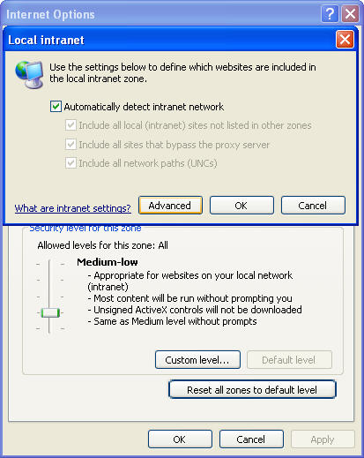

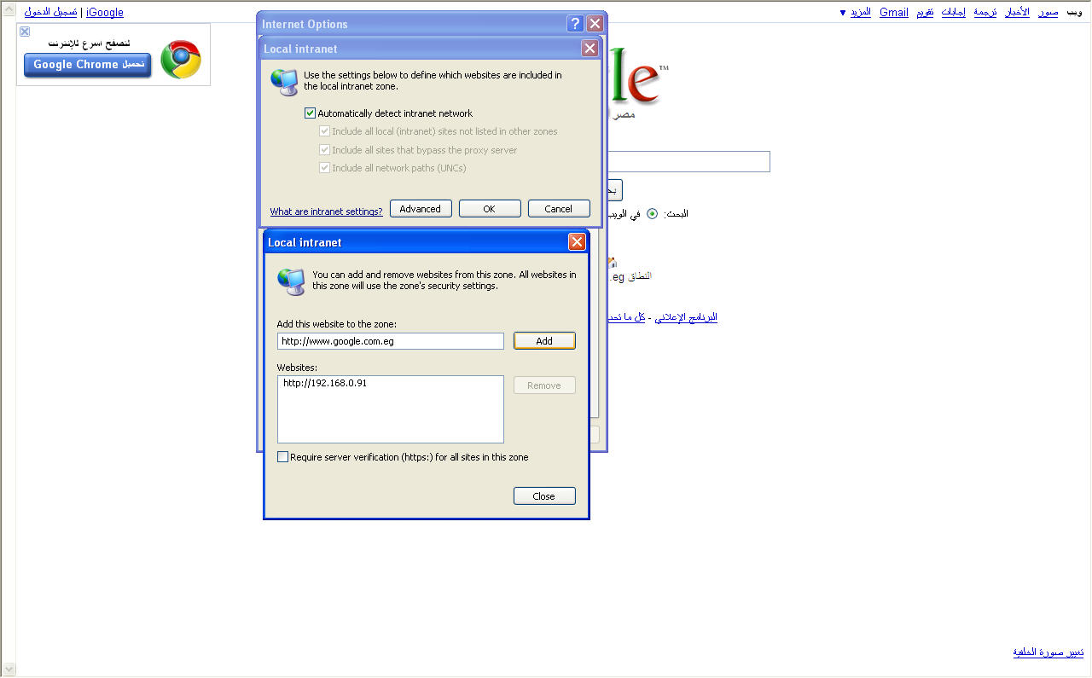

***Firefox settings:***

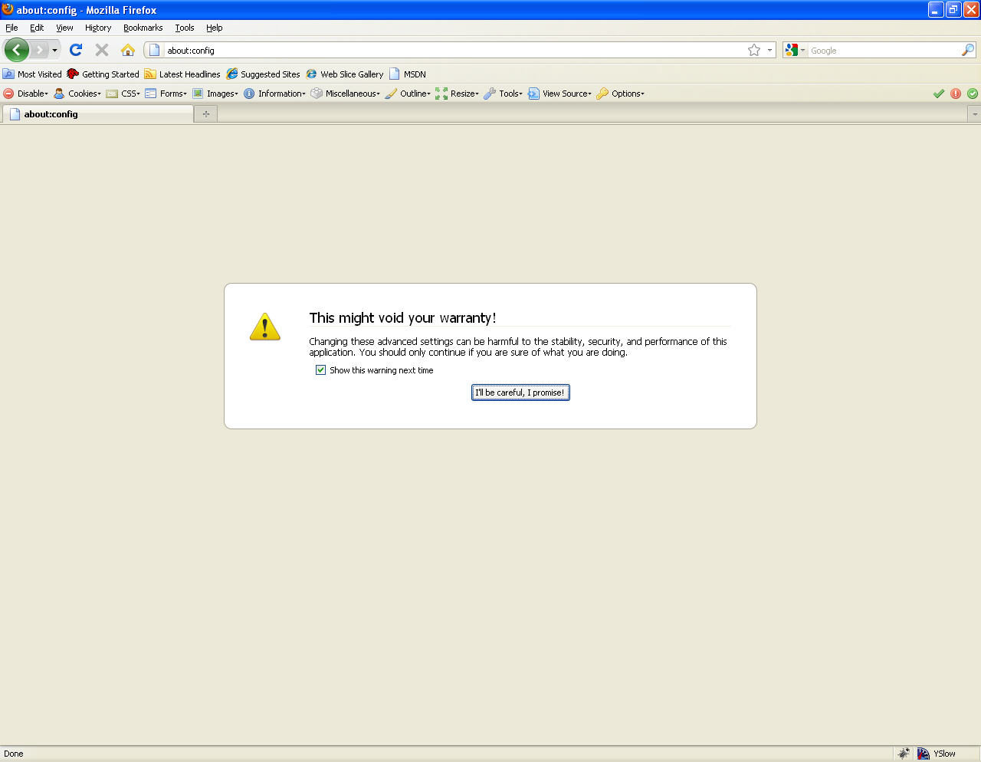**1) Open Firefox and type “about:config” in the address bar. (Without the quotes), then click I will be careful if an alert occurred.**

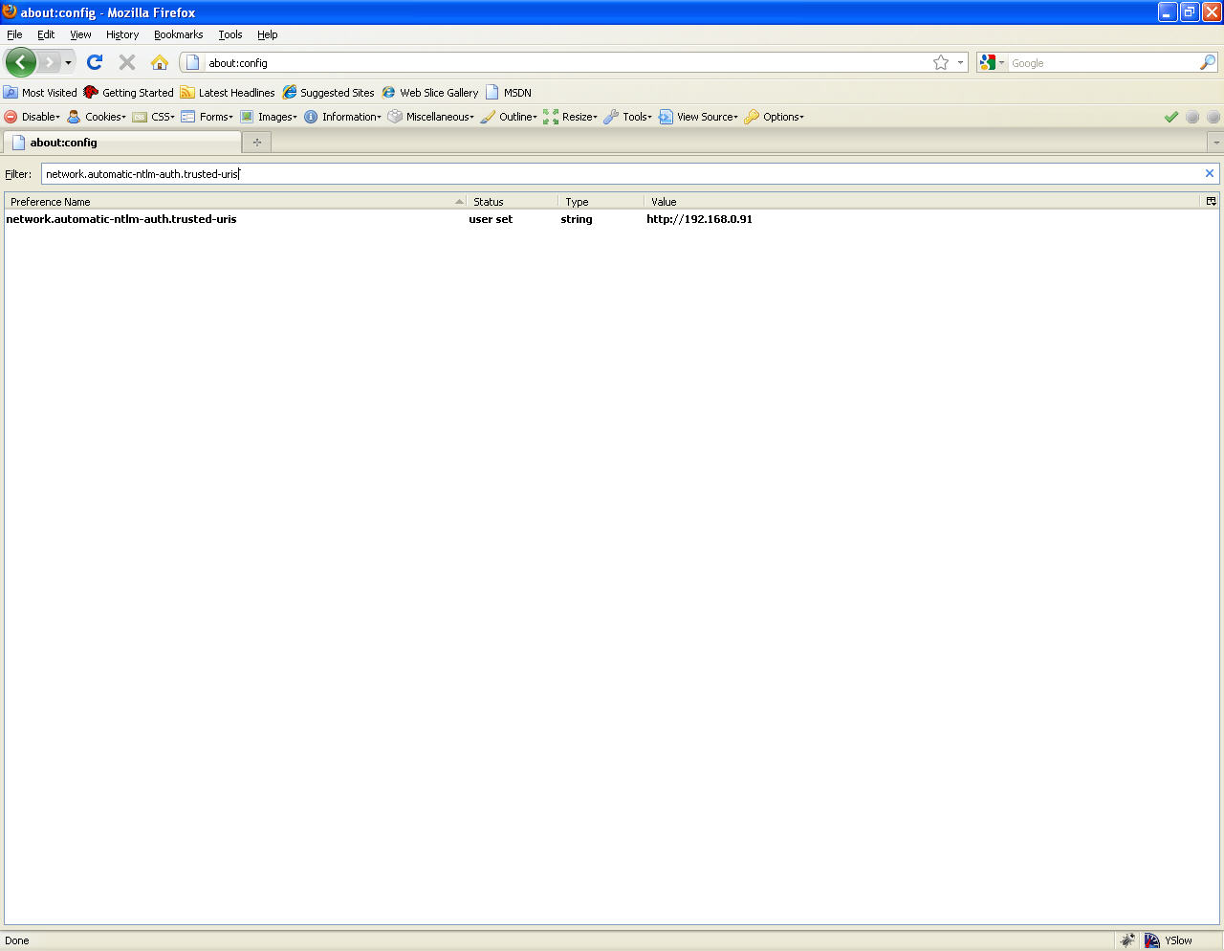**2) In the ‘Filter’ field type the following “network.automatic-ntlm-auth.trusted-uris”**

**3) Double click the name of the preference that we just searched for, Then enter the URLs of the sites you wish to pass NT LAN Manager (NTLM) auth info to in the form :**

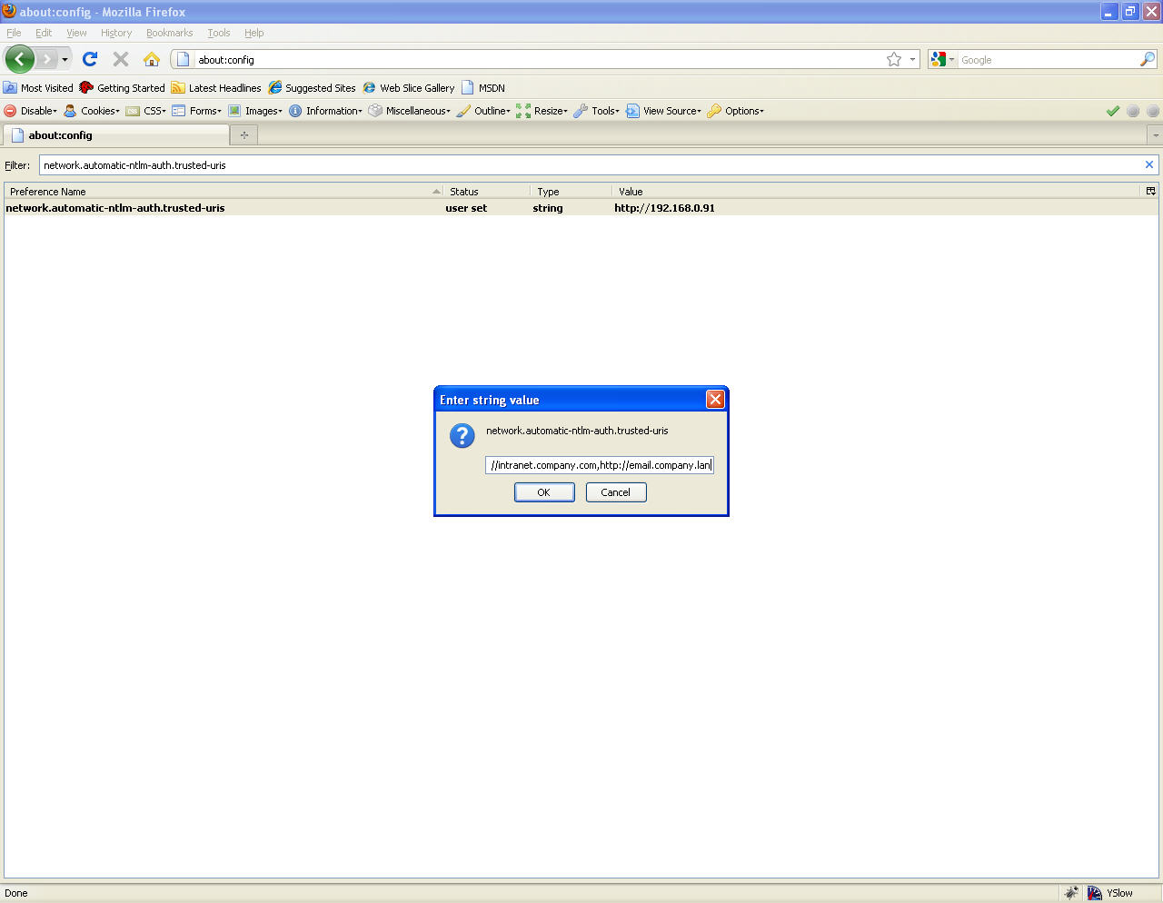<http://intranet.company.com,http://email.company.lan>